Maheshwar R

The task solution description for task 2: A program to find if given 4 integers are sides of a rectangle

The aim is to make a function that takes 4 integers as an argument and returns ‘1’ if they are sides of a rectangle and ‘0’ if not. So my solution is to make a function that can compare two numbers and say if they are equal and then use this comparison to lay out a set of conditions that will make these 4 numbers sides of a rectangle.

**The check function: To check if two numbers are equal**

The quantum circuit (constructed for a particular case) to check if two numbers 5 and 4 (‘101’ and ‘100’ in binary) are equal or not is as shown below,

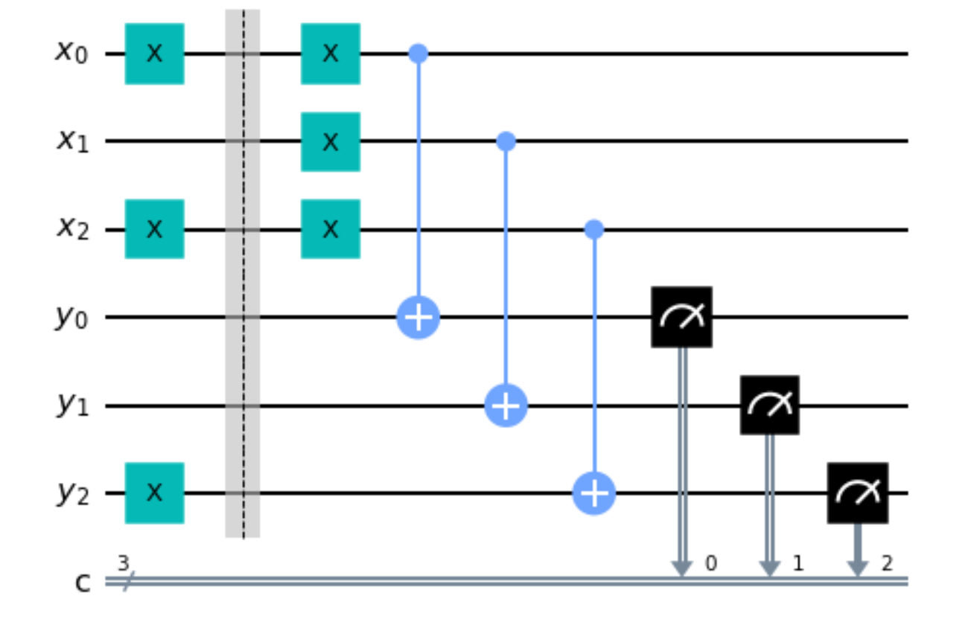

Where if equal, the register ‘y’ will give measurement y2y1y0 = ‘111’. But in the above case of 5 and 4, the output will be ‘110’, indicating that numbers are not equal.

Then we can use a binary string ‘111’ to compare with measurement and return 1 if numbers are equal and 0 if not.

**The is_rectangle function:**

We then use a series of if-elif-else statements to use the check function and give us the final output if a function is rectangle or not. It return 1 if rectangle and 0 if not.